

**SOUND**

SOUND

# PROJECT GROUP MEMBERS

|  |  |
| --- | --- |
| **Students ID** | **Students Name** |
| **Student1385888** | **RAFIA NAJAM** |
| **Student1383991** | **MUHAMMAD ZEESHAN** |
| **Student1340103** | **TULAIB KHAN** |
| **Student1363543** | **SYED MUDASSIR SHAH** |

|  |  |
| --- | --- |
| **CURRICULUM**  **7062** | **BATCH**  **2206B1** |
| **FACULTY**  **“MS. NEELAM MALIK”** | |
| **CO-ORDINATOR “MS.MUNAZZAH KHAN”** | |

 SOUND

# DATABASE CONNECTION

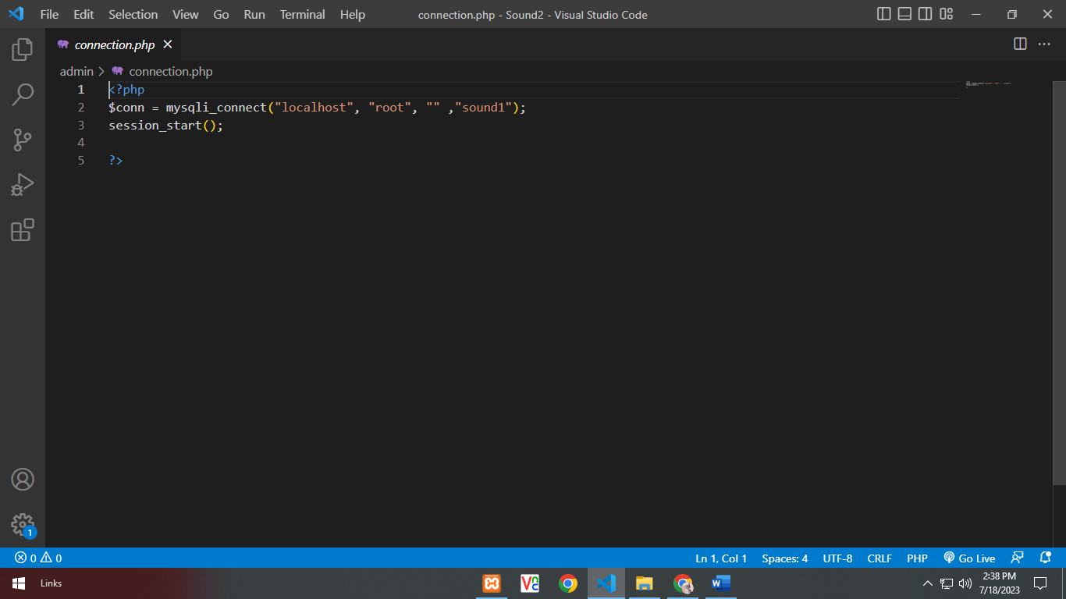



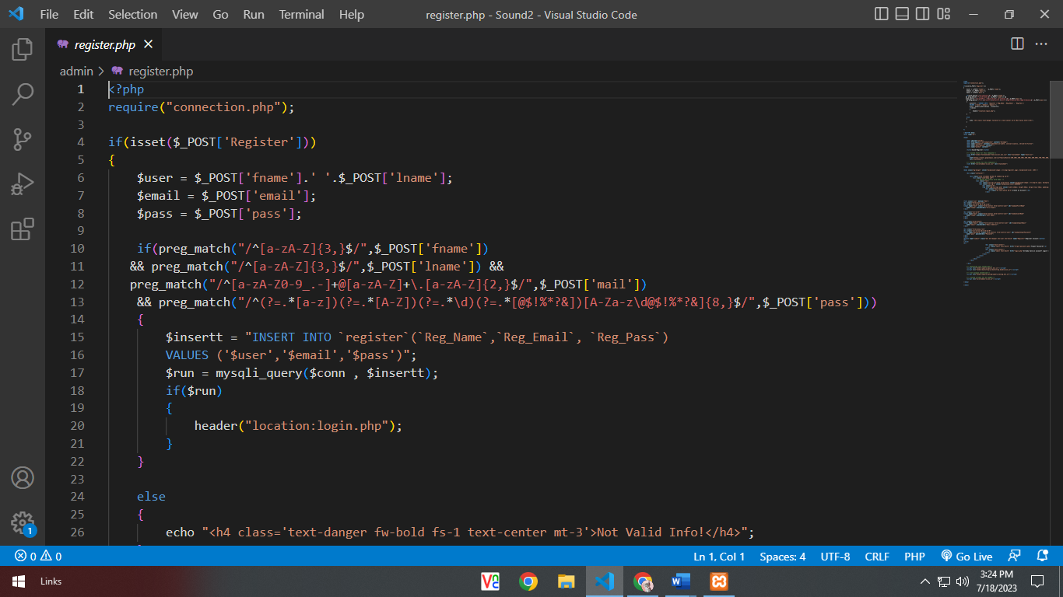**REGISTER**

 SOUND

# LOGIN

SOUND

# LOGOUT

SOUND

# VIDEO LIST

# 

SOUND

# GALLERY

# 

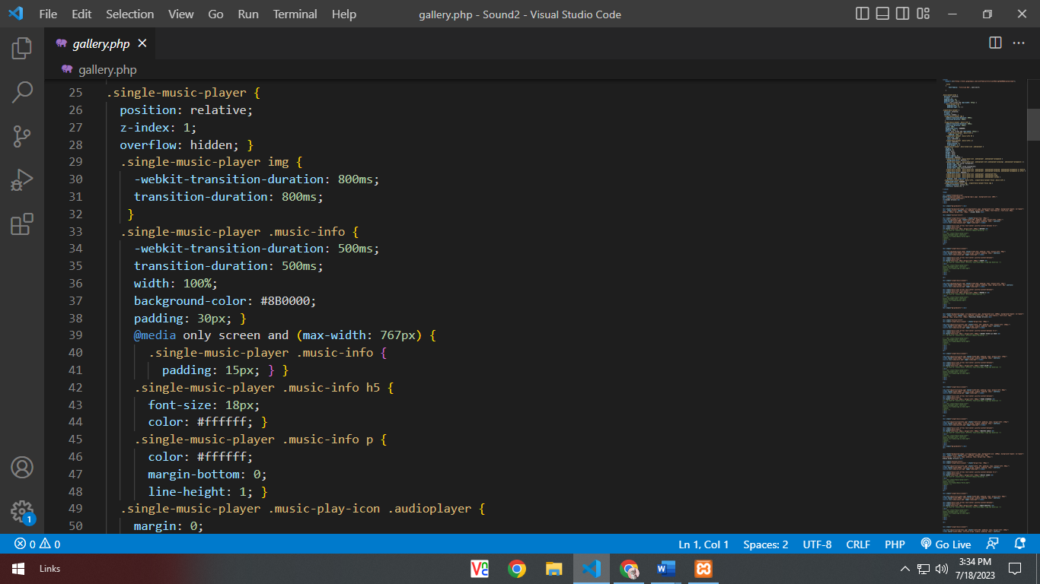SOUND

SOUND

**CONTACT US**

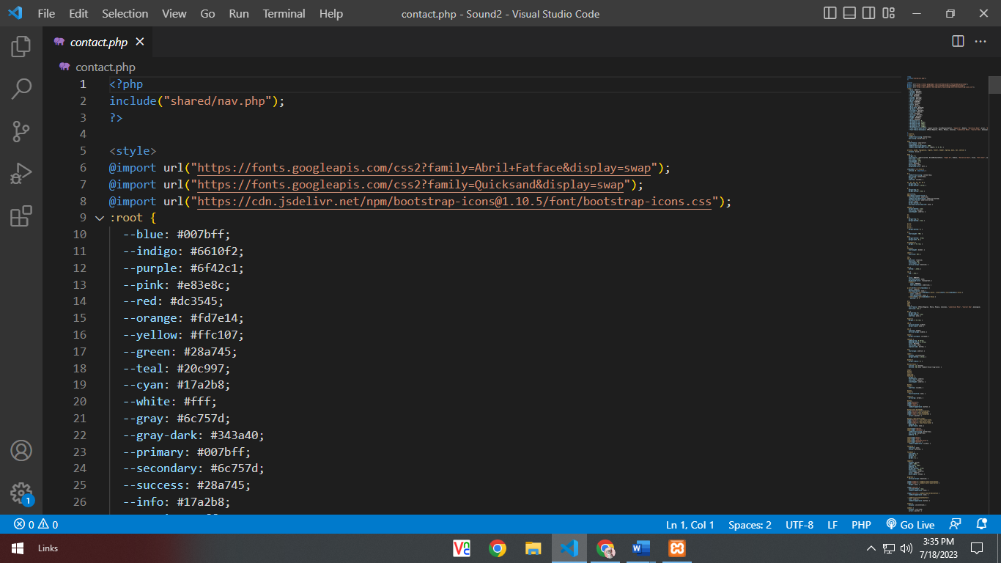

SOUND

# ABOUT US

# 